Question – 01

Find count of jobs type in each dept.

Query:

SELECT dept.DNAME AS 'Departments', COUNT(emp.job) AS 'Job_roles'

FROM dept

INNER JOIN emp

ON emp.deptno = dept.deptno

GROUP BY dept.DNAME;

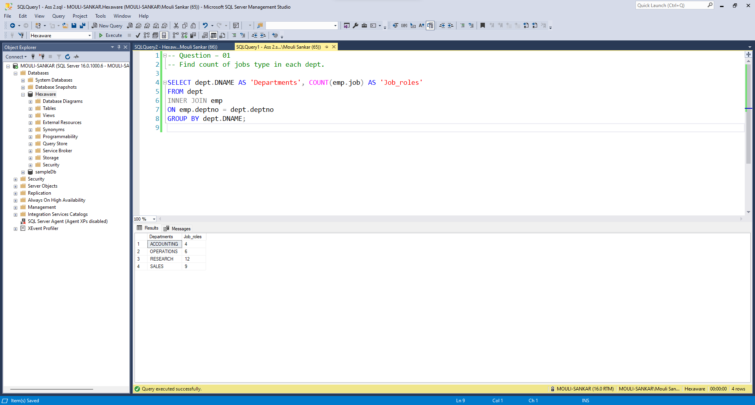

Question – 02

Query to find emp manager name and his manager for employees working in India

Query:

USE Hexaware;

SELECT e1.empno AS Empno,

e1.ename AS Ename,

DENSE_RANK() OVER(ORDER BY e1.ename) AS ManagerNo,

e2.ename AS Manager_Name,

e2.empno AS "Manager's Manager ID",

e3.ename AS "Manager's Manager Name",

l.Country AS Country_Name

FROM emp e1

INNER JOIN emp e2 ON e1.mgr = e2.empno

INNER JOIN emp e3 ON e2.mgr = e3.empno

INNER JOIN dept dept ON e1.deptno = dept.deptno

INNER JOIN loc l ON l.LOC_ID = dept.LOC_ID

WHERE l.Country = 'India';

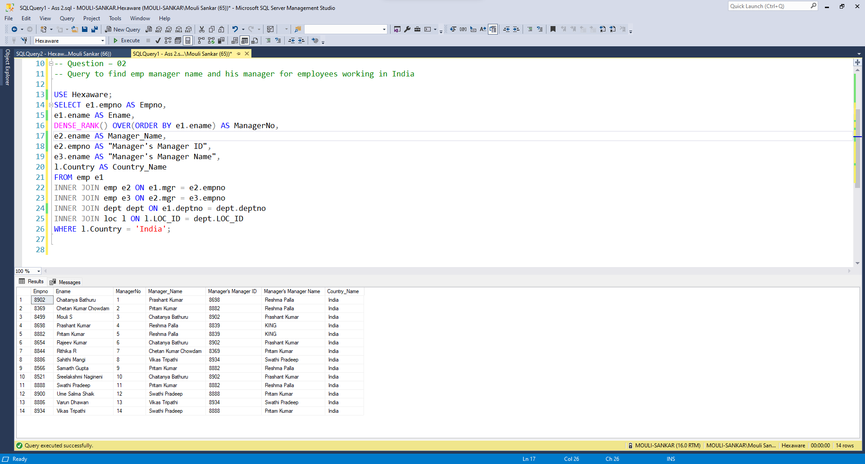

Question – 03

Find Average Salary for each Dept in India for each job type.

Query:

SELECT e.ename, d.DNAME, e.job, AVG(e.sal) AS Average_Salery

FROM emp e

INNER JOIN dept d ON e.deptno = d.deptno

INNER JOIN loc l ON d.LOC_ID = l.LOC_ID

WHERE l.Country = 'India'

GROUP BY e.ename, d.DNAME, e.job;

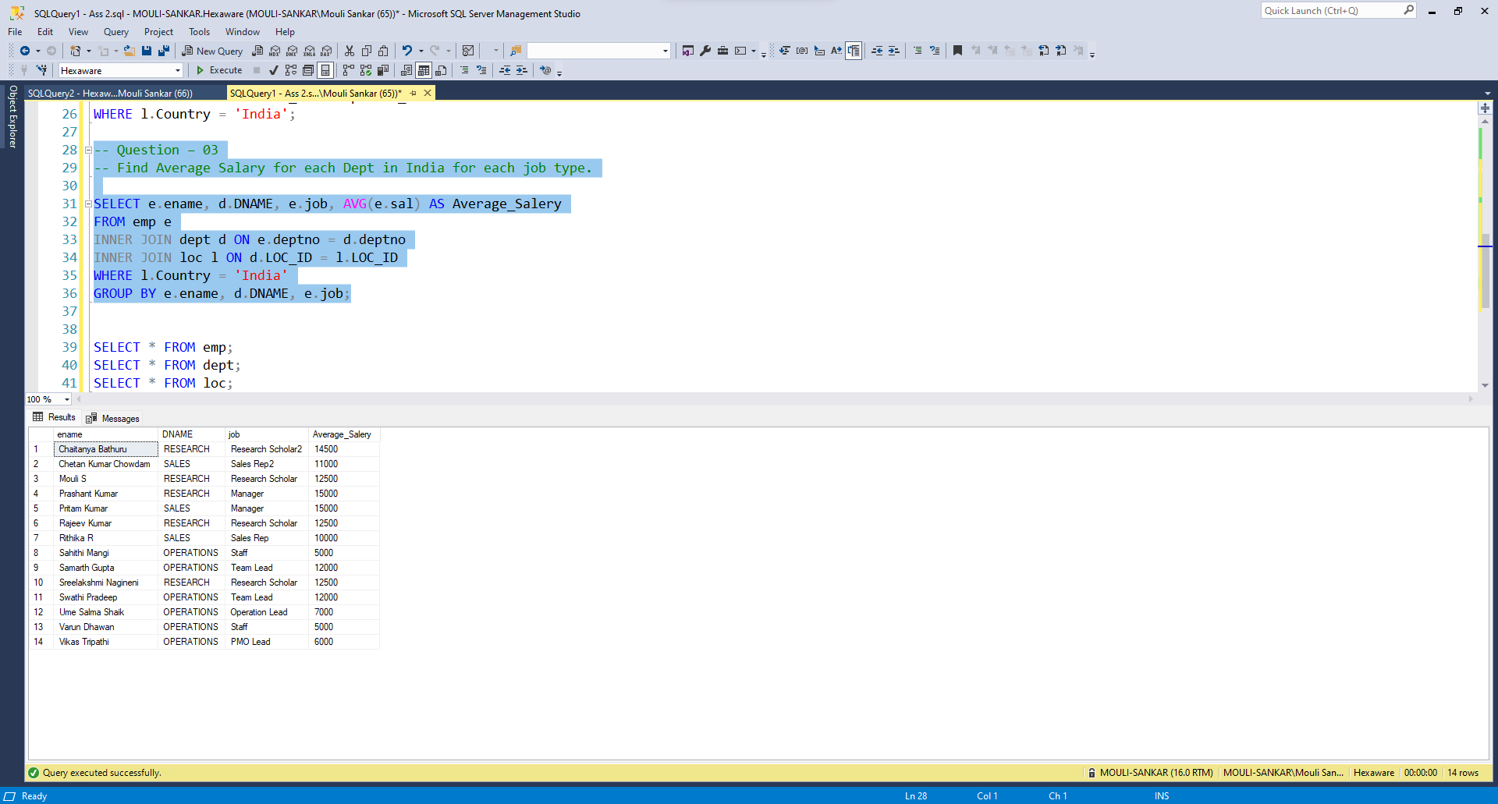

Question – 04

Compare Salary for same job type in India and US

Query:

SELECT d.dname AS deptname, e.job,

'INR' AS currency_in_inr, e.sal AS sal_in_india,

'USD' AS currency_in_usd, e.sal AS sal_in_usa

FROM emp e

JOIN dept d ON e.deptno = d.deptno

JOIN loc l ON d.loc_id = l.loc_id

WHERE l.country = 'India'

UNION

SELECT d.dname AS deptname, e.job,

'INR' AS currency_in_inr, e.sal*72.5 AS sal_in_india,

'USD' AS currency_in_usd, e.sal AS sal_in_usa

FROM emp e

JOIN dept d ON e.deptno = d.deptno

JOIN loc l ON d.loc_id = l.loc_id

WHERE l.country = 'USA'

ORDER BY job, deptname;

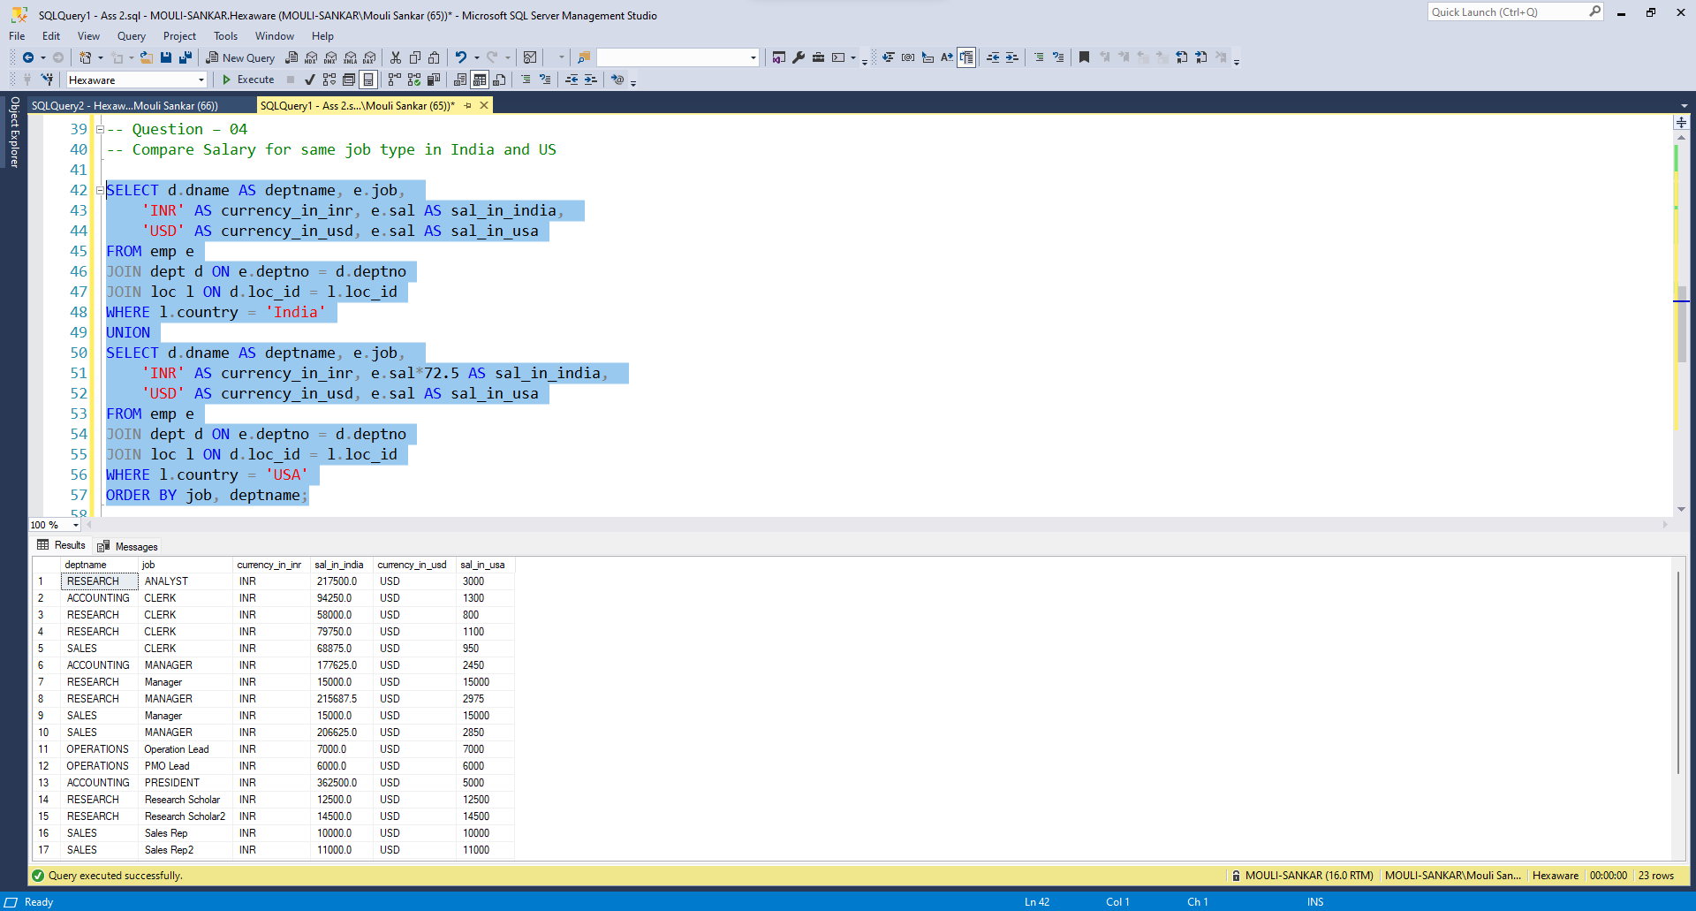

Question – 05

Using SQL query Print “hexaware” like

Query:

SELECT SUBSTR('hexaware', LEVEL, 1)

FROM DUAL

CONNECT BY LEVEL <= LENGTH('hexaware');

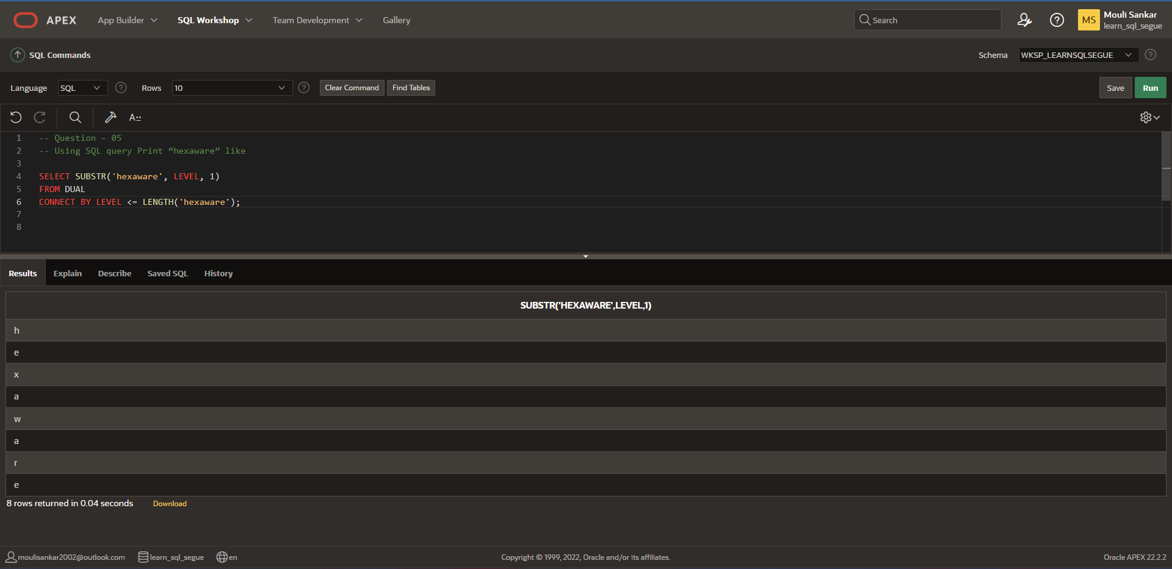

Question – 06

Find the employees in India and US having same job role getting second highest salary in each country by job role.

Query:

SELECT Country, job,empno,ename,sal

FROM (

SELECT e.empno, e.ename, e.sal, e.job, l.Country,

ROW_NUMBER() OVER (PARTITION BY l.Country, e.job ORDER BY e.sal DESC) AS rn

FROM emp e

INNER JOIN dept d ON e.deptno = d.deptno

INNER JOIN loc l ON d.LOC_ID = l.LOC_ID

WHERE l.Country IN ('India', 'USA')

) AS sub

WHERE rn = 2

GROUP BY Country, job,empno,ename,sal

ORDER BY sal DESC;

